# **Name: Abdurrahman Qureshi**

# **Roll No: 210451**

Practical No: 13

**1) Write a program to create following roll over effect in JavaScript Enlarge the image on mouseover event Decrease the image size on mouseout event**

**CODE:**

<!DOCTYPE html>  
<html lang="en">  
<head>  
 <meta charset="UTF-8">  
 <title>Title</title>  
 <style>  
 body{  
 font-family: sans-serif;  
 }  
 img{  
 border-radius: 10px;  
}  
 </style>  
</head>  
<body>  
 <h1>Image Enlarges on "onmouseover" and goes <br> back to normal size "onmouseout" Event</h1>  
 <br><br>  
 <img id="myImg" src="../img/pic2.jpeg" alt="">  
 <script>  
 const ***myImg*** = ***document***.getElementById("myImg")  
 ***myImg***.addEventListener('mouseover',function(){  
 ***myImg***.style.width = "500px";  
 ***myImg***.style.height = "300px";  
 ***myImg***.style.transition = "0.5s ease all"  
 })  
 ***myImg***.addEventListener('mouseleave',function(){  
 ***myImg***.style.width = "200px";  
 ***myImg***.style.height = "100px";  
 })  
 </script>  
</body>  
</html>

**OUTPUT:**

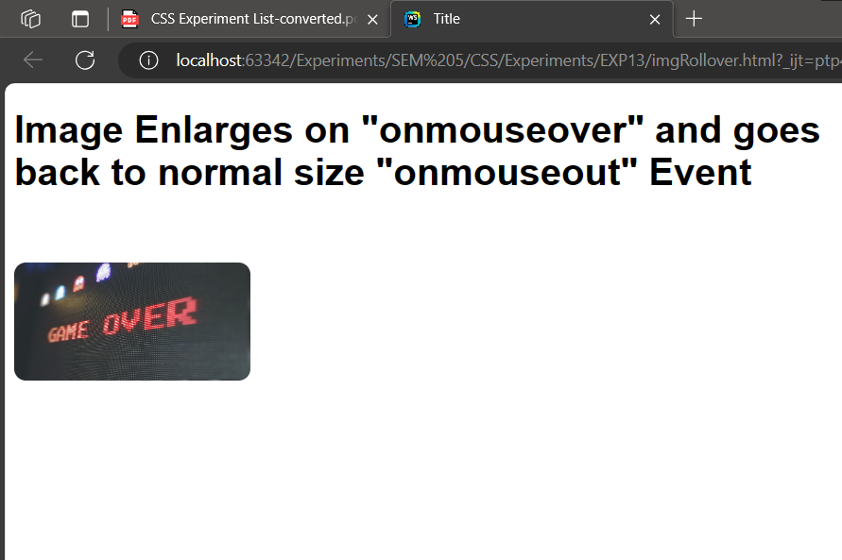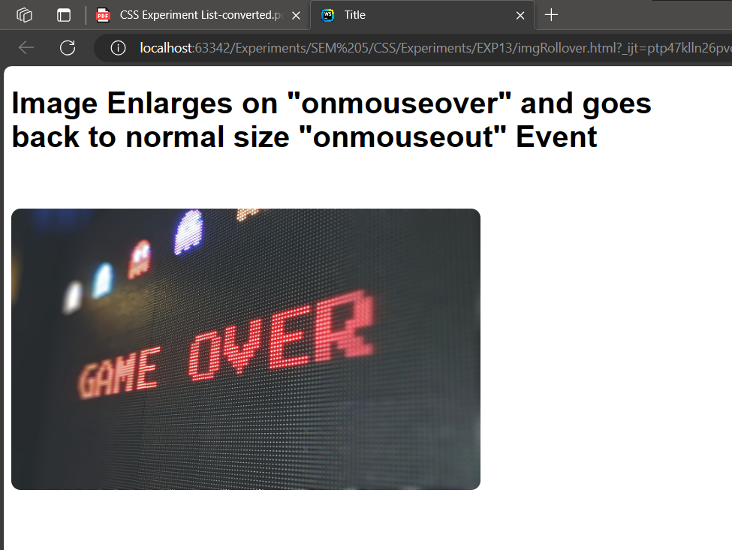

**2) Write a program to create roll over effect on an HTML element via “hover”**

**CODE:**

<!DOCTYPE html>  
<html>  
<head>  
 <style>  
 body{  
 font-family: sans-serif;  
 height: 100vh;  
 display: flex;  
 flex-direction: column;  
 justify-content: center;  
 align-items: center;  
 }  
 button{  
 background-color: #cccccc;  
 color: #1a1a1a;  
 width: 10rem;  
 height: 3rem;  
 font-size: 2rem;  
 border-radius: 10px;  
 transition: 0.5s all ease;  
 border: 2px #cccccc solid; }  
 button:hover{  
 width: 15rem;  
 border: 2px #1a1a1a solid;  
 background-color: #1a1a1a;  
 color: #cccccc;  
 cursor: pointer; }  
 </style>  
</head>  
<body>  
 <h1>Element Rollover</h1><br>  
 <button>Click me</button>  
</body>

</html>

**OUTPUT:**

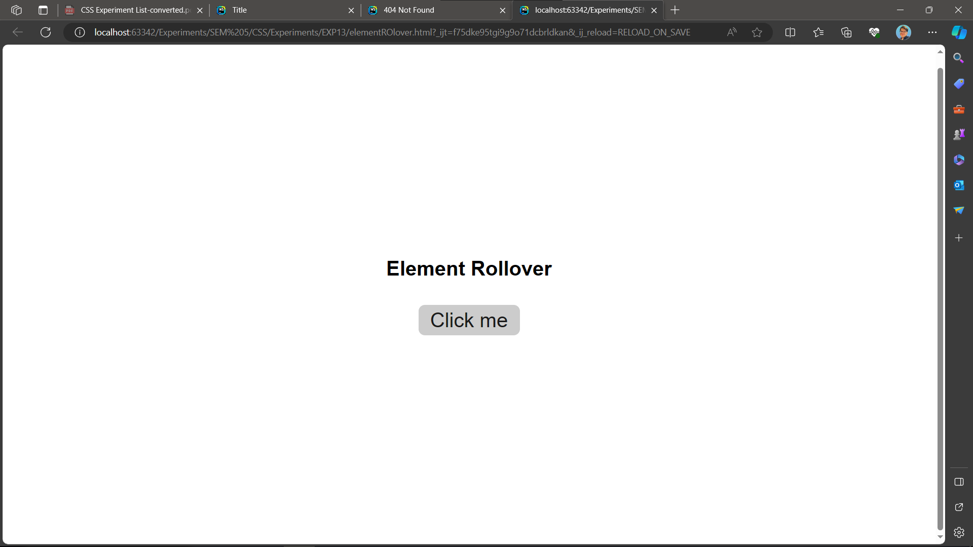

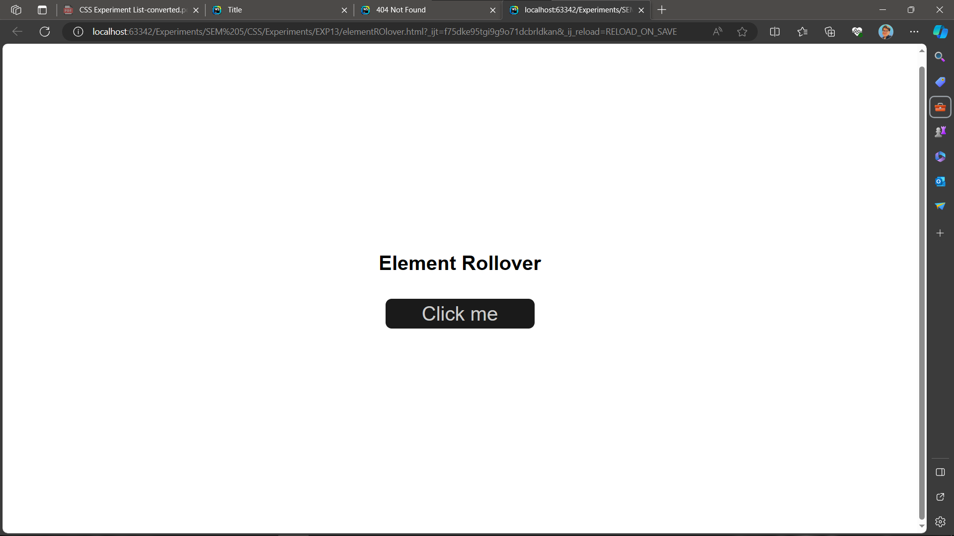

**3) Write a program to create roll over effect on text.**

**CODE:**

<html lang="en">  
<head>  
 <meta charset="UTF-8">  
 <meta name="viewport" content="width=device-width, initial-scale=1.0">  
 <title>Document</title>  
 <style>  
 img{  
 width: 40rem;  
 height: 30rem;  
 object-fit: cover;  
 border-radius: 10px;  
 }  
 </style>  
</head>  
<body>  
 <img id="myImg" src="../Practical%20Playgorund/img/pic1.jpeg" alt="">  
 <p onclick="changeRollOver(0)">Change to pic A</p>  
 <p onclick="changeRollOver(1)">Change to pic B</p>  
 <p onclick="changeRollOver(2)">Change to pic C</p>  
  
 <script>  
 let ***rollOverArray***= ["../img/pic1.jpeg","../img/pic2.jpeg","../img/pic3.jpeg",]  
 function changeRollOver(index){  
 const myImg = ***document***.getElementById("myImg")  
 myImg.src = ***rollOverArray***[index]  
 }  
 </script>  
</body>  
</html>

**OUTPUT:**

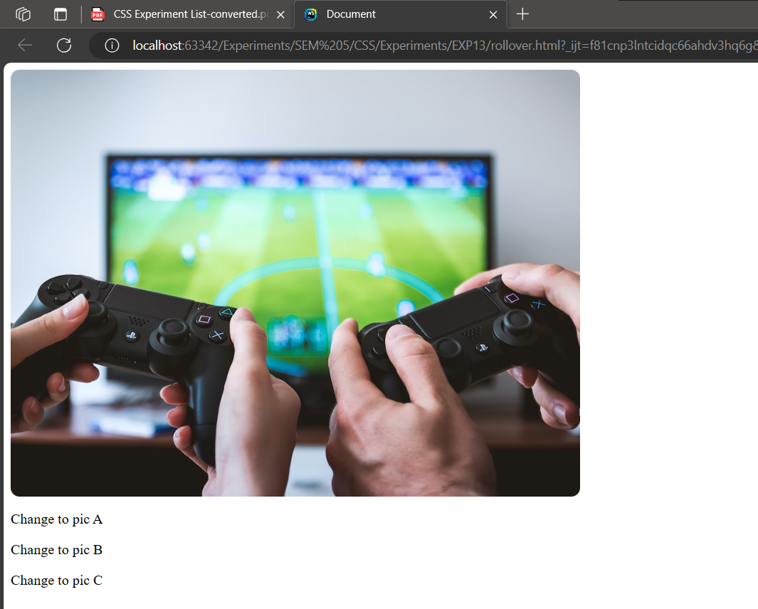

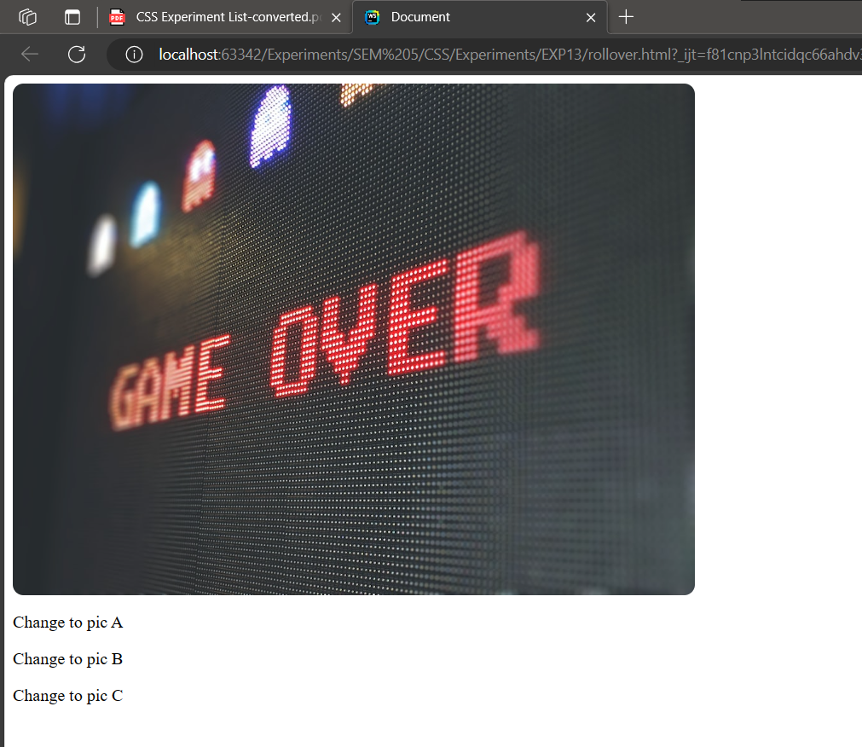

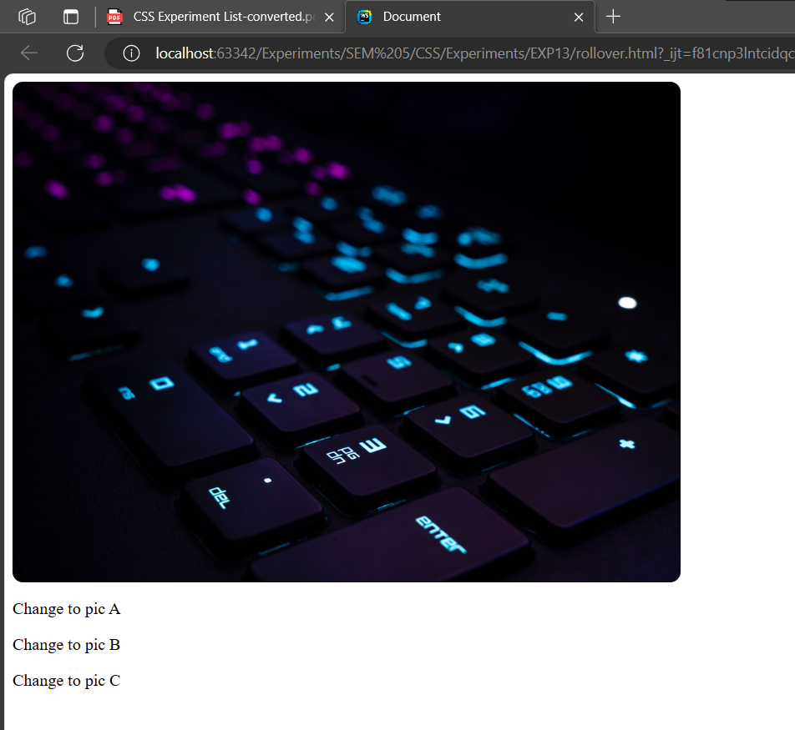

**4) Write a program to create roll over effect on image.**

**CODE:**

<!DOCTYPE html>  
<html lang="en">  
<head>  
 <meta charset="UTF-8">  
 <title>Title</title>  
 <style>  
 body{  
 font-family: sans-serif; }  
 img{  
 border-radius: 10px; }  
 </style>  
</head>  
<body>  
<img id="myImg" src="../img/pic1.jpeg" alt="">  
<script>  
 const ***myImg*** = ***document***.getElementById("myImg")  
 ***myImg***.addEventListener('mouseover',function(){  
 ***myImg***.style.width = "800px";  
 ***myImg***.style.height = "600px";  
 ***myImg***.style.transition = "0.5s ease all"  
 ***myImg***.style.cursor = "pointer"  
 })  
 ***myImg***.addEventListener('mouseleave',function(){  
 ***myImg***.style.width = "500px";  
 ***myImg***.style.height = "350px";  
 })  
</script>  
</body>  
</html>

**OUTPUT:**

